DESIGNING VISUALLY APPEALING CERTIFICATE FOR DEBATE COMPETITION USING CANVA

Project report template:

INTRODUCTION

* 1. OVER VIEW:

The speech and debate competition award certificate is an official document provided to the participant by higher management as a token of appreciation. These awards motivate non-participants to take part in such activities and get appreciated by other people for their talent and skills.

* 1. PURPOSE:

Speech and debate competitions are organized to promote awareness about particular subjects and students are encouraged to participate wholeheartedly. These speeches are evaluated based on a number of factors i.e. delivery, vocabulary, content, and timing. Mostly, winners of these competitions are awarded prizes and certificates to encourage their participation

* **Winner’s information:** name, the title of the speech, age, and profession are mentioned on the certificate to easily recognize a winner.
* **Organizers information:** since these award competitions are organized at the provisional or country level as well, therefore, they are handled by organizers. The name, logo, contact information, and other related details are mentioned on the certificate.
* **Title:** title of the award is mentioned on the certificate.
* **Date:** date, time, and location of the award show are mentioned on every certificate

2. PROBLEM DEFINITION & DESIGNING THINKING:

2.1 Empathy Map:

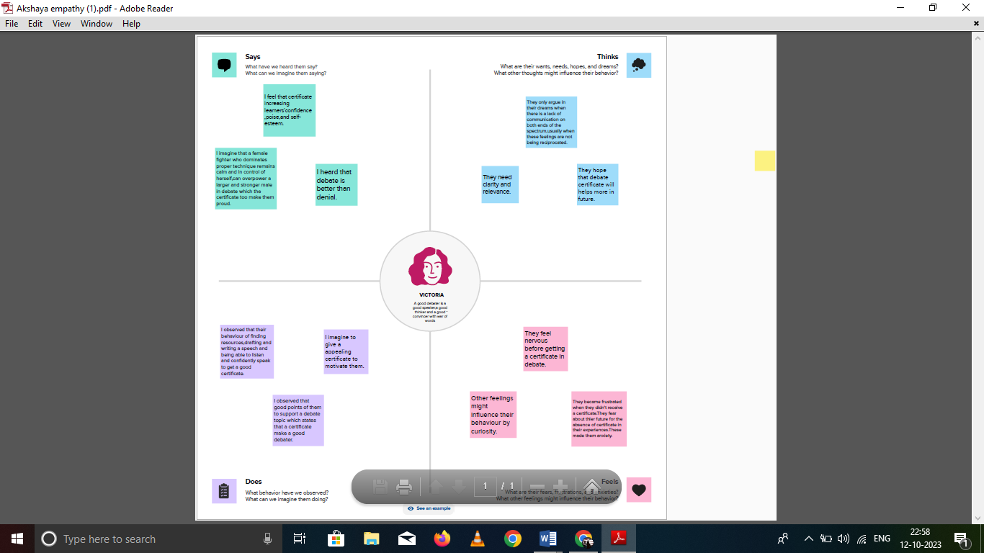

* 1. Ideation & Brainstorming:
  2. 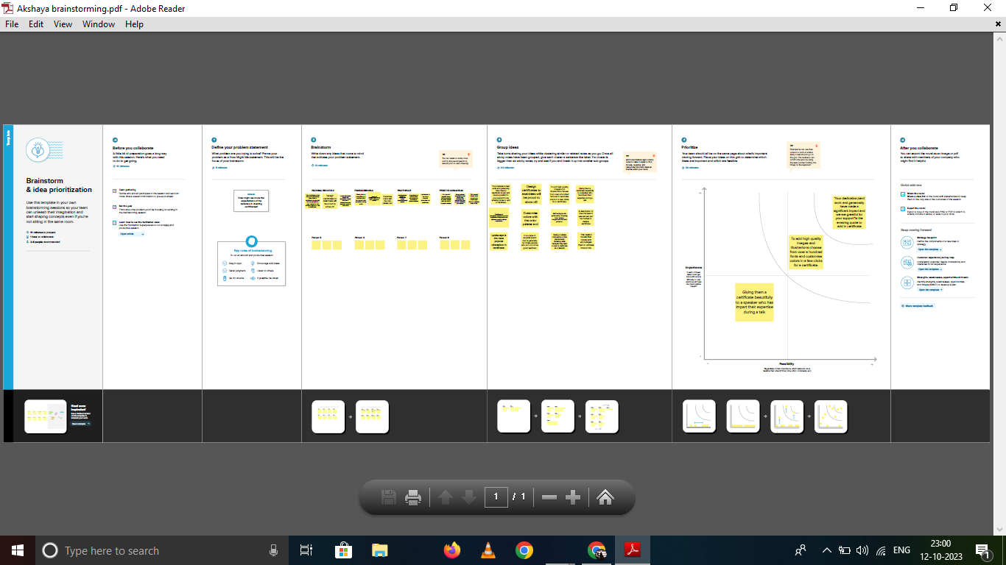

1. RESULT:

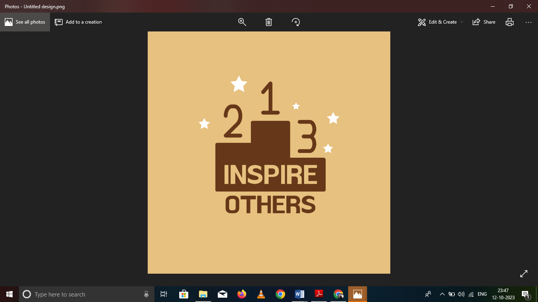

1. ADVANTAGES AND DISADVANTAGES:

* **Advantage**: recognition and credit
* **Advantage**: structured learning
* **Advantage**: integrated and holistic approach
* **Disadvantage**: arrogance
* **Disadvantage**: biases
* **Common problem**: shortcuts

1. APPLICATION:

we feel that debating is important to develop our skill of speaking. It helps us to broaden our outlook and develop our ability to gather knowledge from various sides around us. It also helps us to be prepared for the future leadership

1. CONCLUSION:

Overall, I do recommend aiming for certifications, but I also suggest being aware of and managing the disadvantages.